FLASK & MONGODB ATLAS
DEVOPS ASSIGNMENT – PROJECT DOCUMENTATION
Student: Manvendra Singh
Project Folder: Flask_and_MongoDB_Manvendra
GitHub: https://github.com/manvendra8830-rgb/Flask-And-Mongodb
Application: Flask + MongoDB Atlas

1. Assignment Objective
The objective is to build a Flask application with a JSON API route and a frontend form that stores submitted data in MongoDB Atlas, with proper success and error handling.
- Task 1: Create an /api route that reads a JSON list from a backend file and returns it as JSON.
- Task 2: Create a frontend form that inserts submitted data into MongoDB Atlas.
- On success, redirect to another page displaying “Data submitted successfully”.
- On error, display the error on the same page without redirection.

2. Technologies Used
- Python
- Flask
- MongoDB Atlas
- PyMongo
- HTML
- CSS
- python-dotenv
- Git and GitHub

3. Project Structure
Flask_and_MongoDB_Manvendra/
├── app.py
├── requirements.txt
├── README.md
├── .gitignore
├── .env.example
├── backend/
│ └── data.json
├── templates/
│ ├── index.html
│ └── success.html
└── static/
└── style.css
The project separates the Flask application, backend JSON data, templates, static styling, dependency configuration, and environment configuration.

4. Environment Setup
A Python virtual environment was created and the project dependencies were installed.
cd ~/Flask_and_MongoDB_Manvendra
python3 -m venv venv
source venv/bin/activate
pip install -r requirements.txt
The application was run locally with:
python3 app.py
Local application URL:
http://127.0.0.1:5000
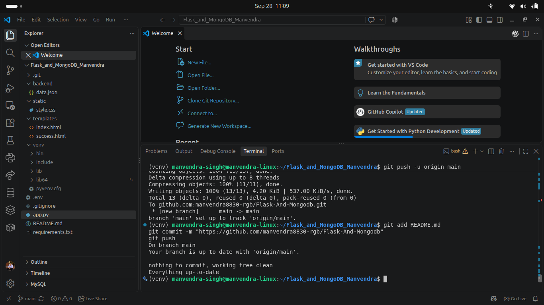
Figure 1: Project terminal showing the local development environment.
The MongoDB connection string is stored in the local .env file and excluded from Git using .gitignore. Sensitive credentials are not included in this report.

5. MongoDB Atlas Configuration

5.1 Network Access
MongoDB Atlas Network Access was configured to allow the local application to connect to the cluster.
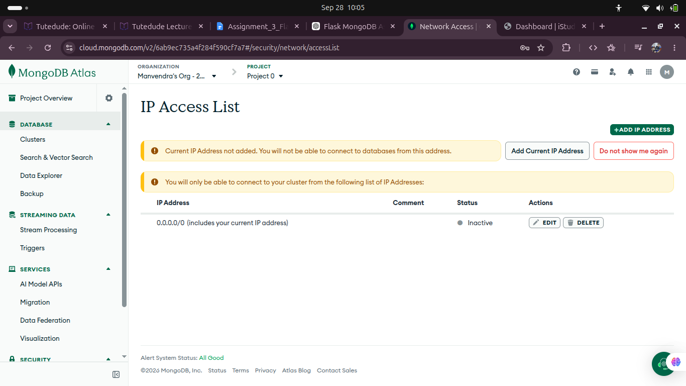
Figure 2: MongoDB Atlas IP Access List.

5.2 Database User
A MongoDB Atlas database user was configured for application authentication.
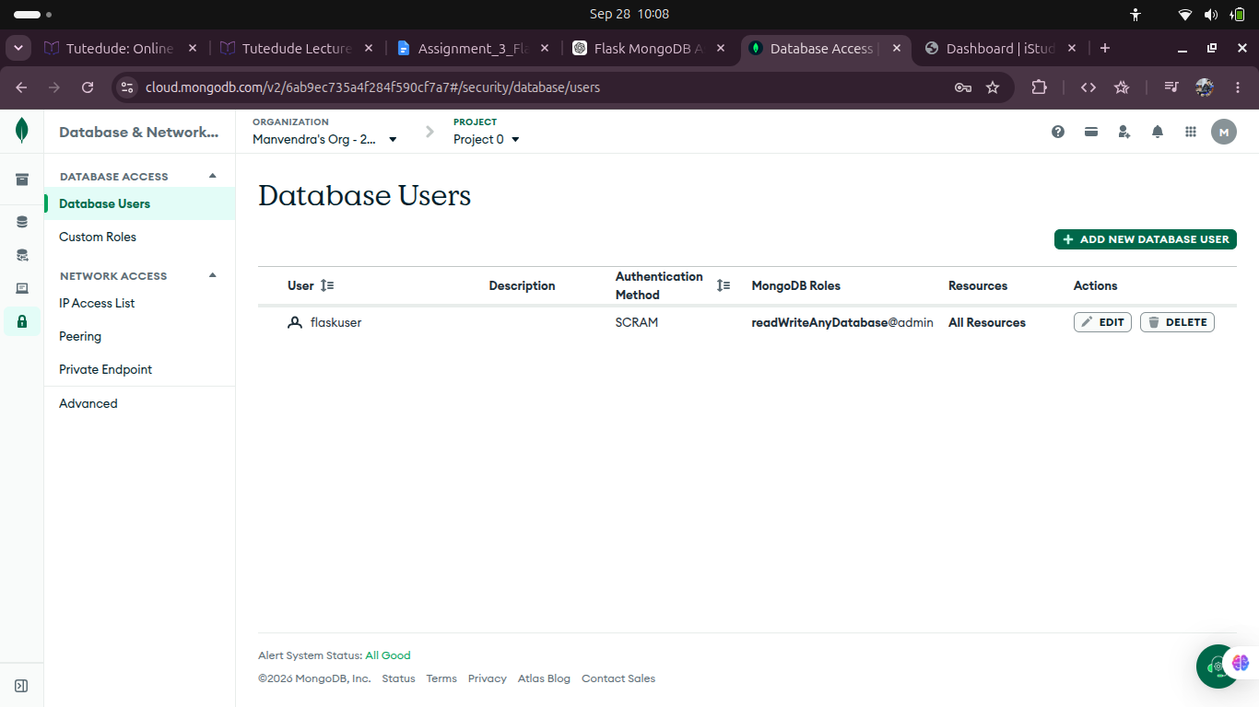
Figure 3: MongoDB Atlas database user.

5.3 Cluster
A free Atlas cluster was created for development and testing.
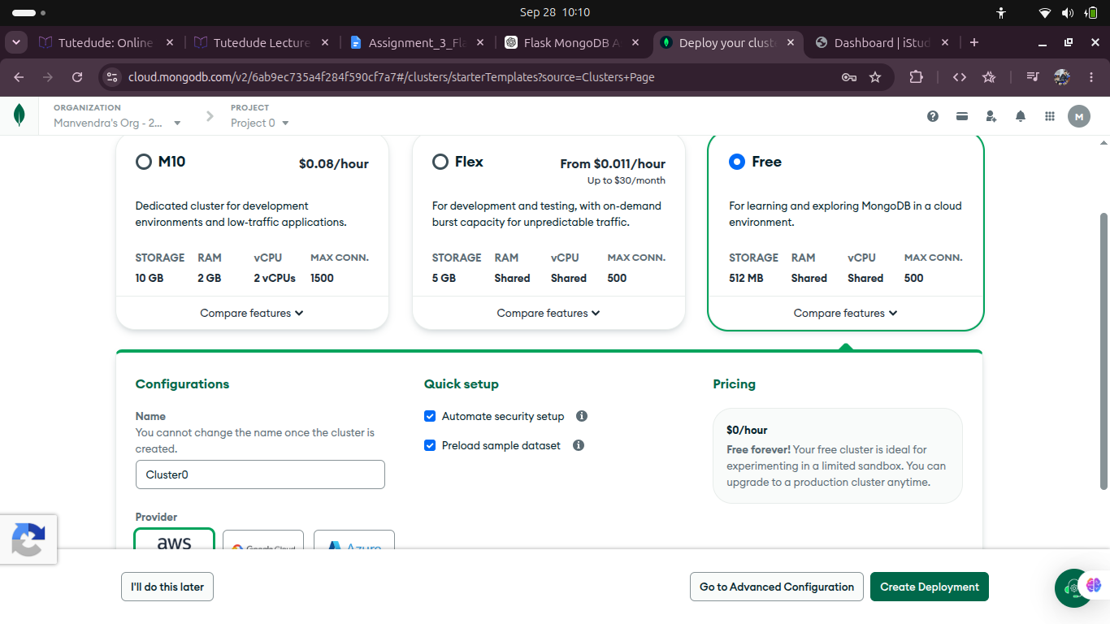
Figure 4: MongoDB Atlas free cluster configuration.
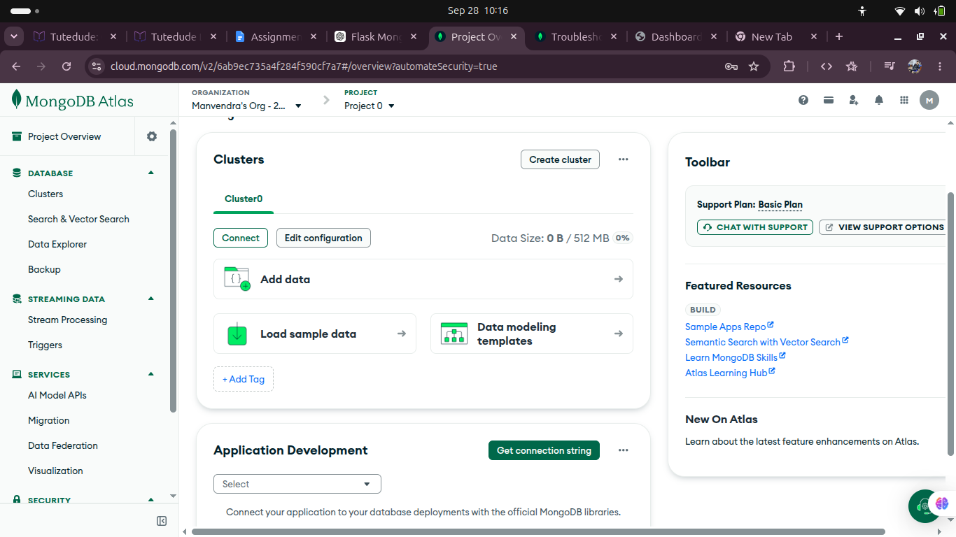
Figure 5: Created Cluster0 in MongoDB Atlas.
The Atlas connection string was copied into the local .env configuration. The password is intentionally not reproduced in the report.

6. Task 1 – JSON API Route
The JSON list is stored in backend/data.json. The Flask /api route reads this file and returns its contents as a JSON response.

6.1 Backend JSON Data
[
{"id": 1, "name": "Manvendra", "course": "DevOps"},
{"id": 2, "name": "Flask", "course": "Web Development"},
{"id": 3, "name": "MongoDB", "course": "Database"}
]

6.2 API Endpoint
GET http://127.0.0.1:5000/api
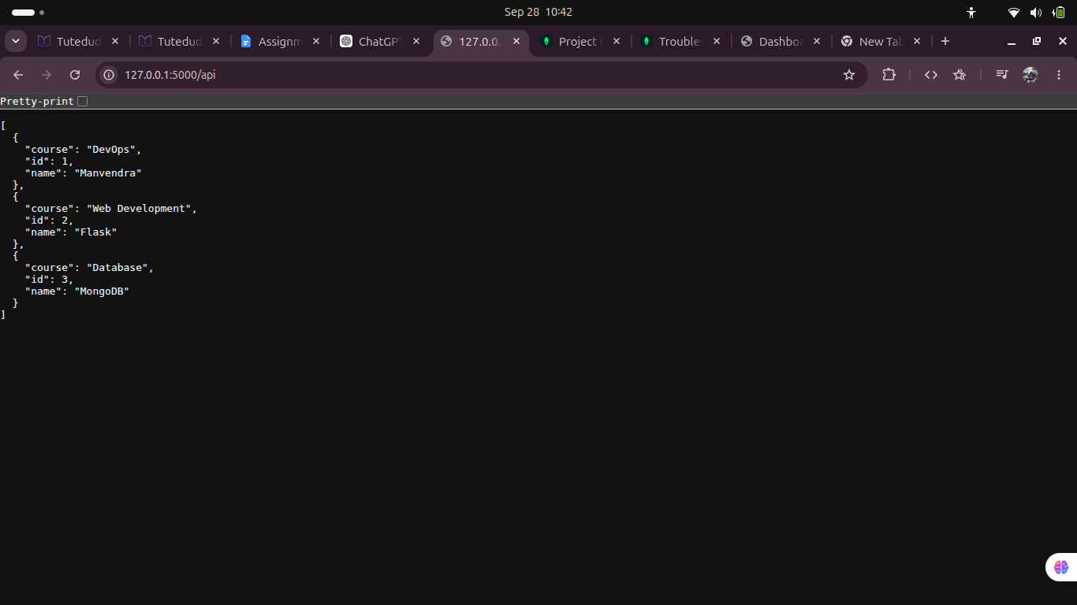
Figure 6: /api route returning the JSON list from backend/data.json.
Result: Task 1 was successfully implemented and verified.

7. Task 2 – Frontend Form with MongoDB Atlas
The frontend provides Name, Email, and Message fields. Valid form submissions are processed by Flask and inserted into MongoDB Atlas.
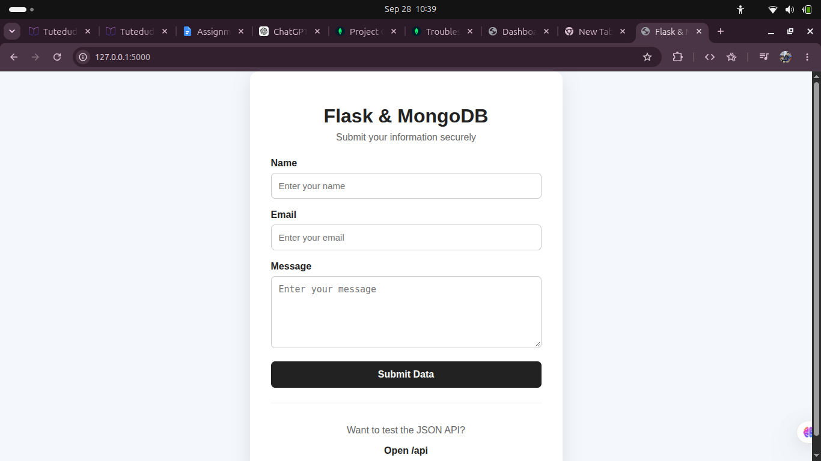
Figure 7: Frontend form used for submission.
Database: flask_db
Collection: submissions

8. Success Handling
After successful insertion, the application redirects the user to the success page.
http://127.0.0.1:5000/success
Required success message:
Data submitted successfully
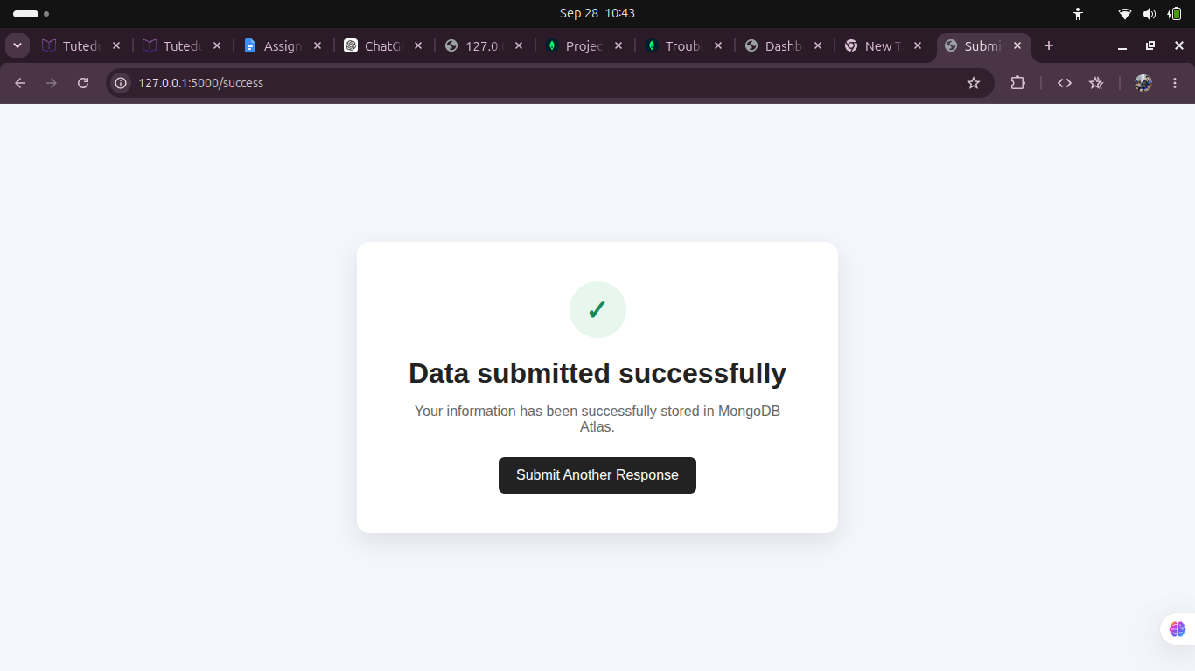
Figure 8: Successful submission and required success message.
Result: Success redirection requirement verified.

9. MongoDB Atlas Data Verification
The submitted data was verified directly in MongoDB Atlas under flask_db → submissions.
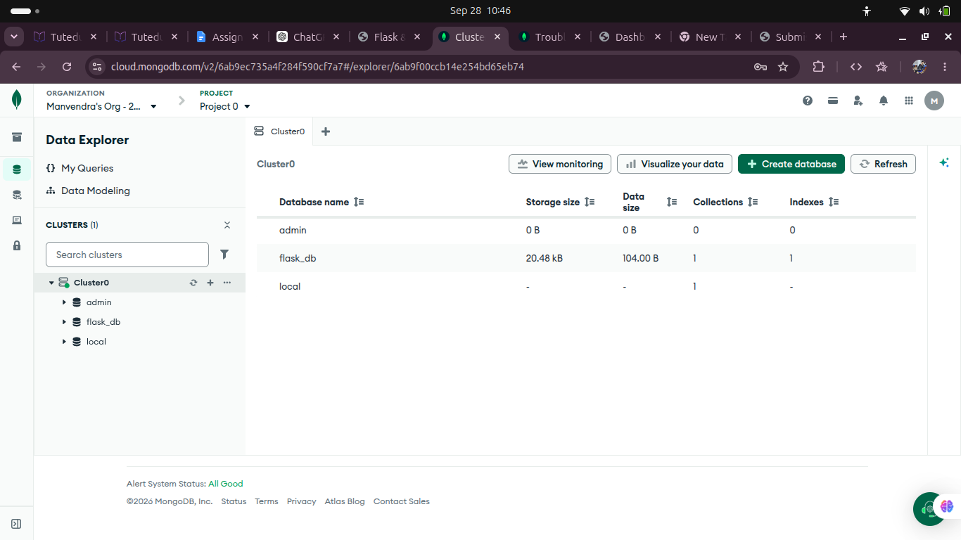
Figure 9: flask_db database visible in MongoDB Atlas.
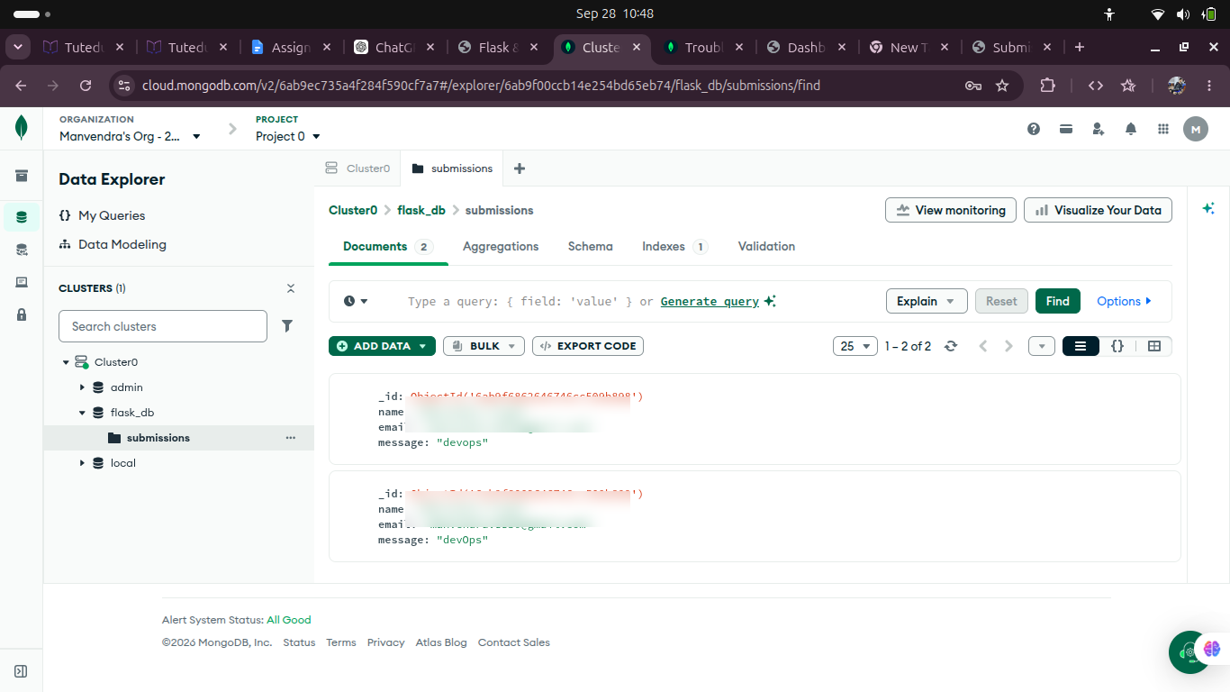
Figure 10: submissions collection containing the submitted documents. Email values are privacy-redacted in this report.
Result: Form data was successfully stored and verified in MongoDB Atlas.

10. Error Handling
If required form fields are missing, the application displays the error on the same form page and does not redirect to the success page.
Error: All fields are required.
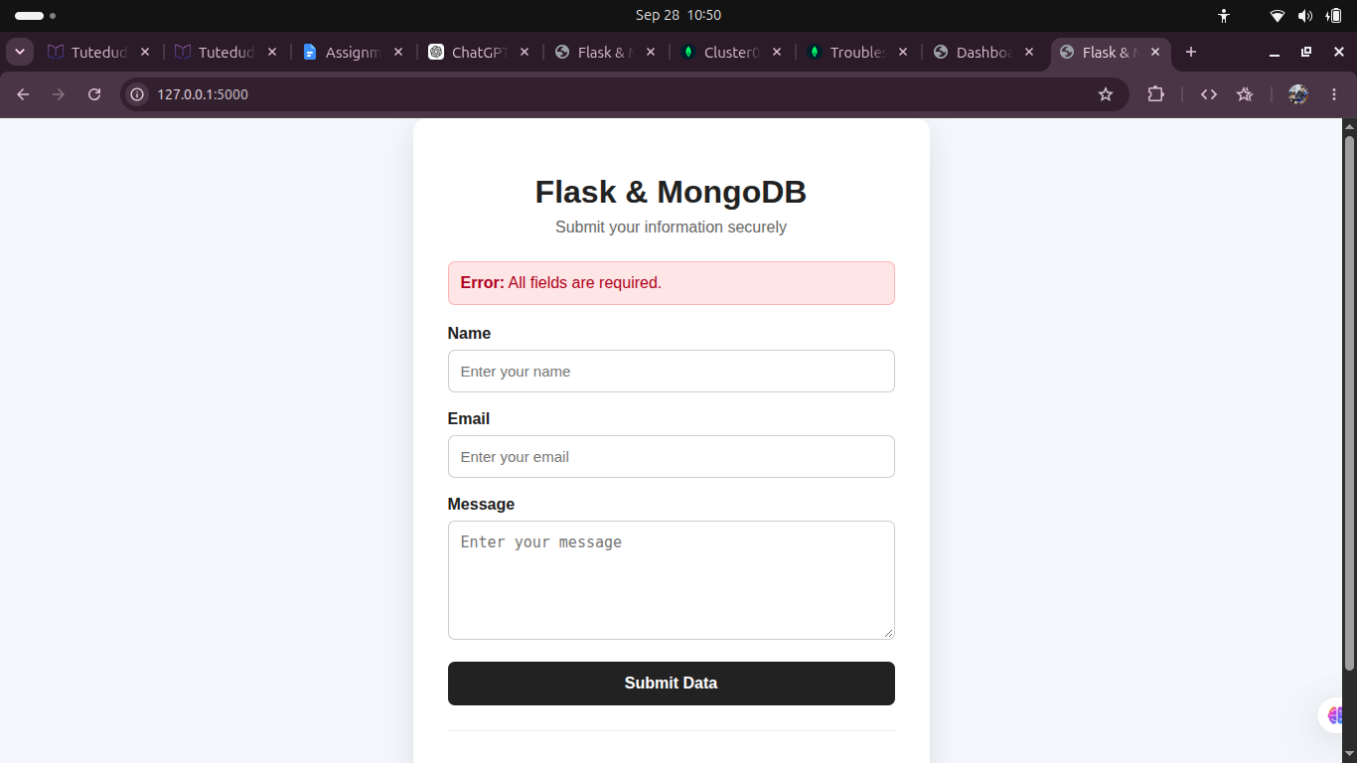
Figure 11: Validation error displayed on the same form page.
Result: Same-page error handling requirement verified.

11. Security and Credential Handling
- MongoDB credentials are stored in the local .env file.
- .env is excluded from version control through .gitignore.
- The public GitHub repository does not contain the MongoDB password.
- An .env.example file is provided as a safe configuration template.
- Sensitive credentials are not reproduced in this documentation.

12. Testing Summary
Test Case | Expected Result | Status
/api route | Returns JSON list from backend/data.json | PASS
Valid form submission | Data inserted into MongoDB Atlas | PASS
Success handling | Redirects to /success and shows required message | PASS
MongoDB verification | Document visible in submissions collection | PASS
Missing required fields | Error shown on same form page | PASS
GitHub security | .env/password not published | PASS

13. GitHub Repository
The complete source code was pushed to the following public repository:
https://github.com/manvendra8830-rgb/Flask-And-Mongodb
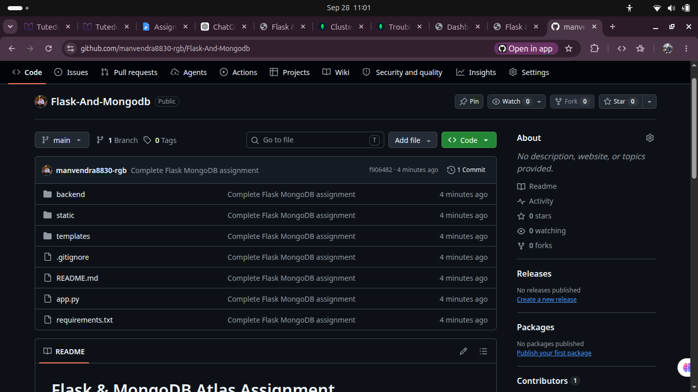
Figure 12: GitHub repository containing the project source code.
The repository contains the source code, backend JSON file, templates, static files, requirements.txt, README.md, and .gitignore. The local virtual environment and .env credentials are excluded.

14. Important Commands Used
# Create virtual environment
python3 -m venv venv
source venv/bin/activate
# Install dependencies
pip install -r requirements.txt
# Run application
python3 app.py
# Git workflow
git init
git add .
git commit -m "Complete Flask MongoDB assignment"
git branch -M main
git remote add origin <GitHub-Repository-URL>
git push -u origin main

15. Submission Checklist
- ✓ Complete Flask application code
- ✓ Backend JSON file
- ✓ Frontend templates and CSS
- ✓ requirements.txt
- ✓ README.md
- ✓ .gitignore and .env.example
- ✓ MongoDB Atlas integration
- ✓ Documentation with screenshots, commands, and explanations
- ✓ GitHub repository link
- ✓ Final project folder named Flask_and_MongoDB_Manvendra
- ✓ Final ZIP named Flask_and_MongoDB_Manvendra.zip
Before creating the final ZIP, the local .env file and venv directory must not be included. The ZIP should contain the complete project source code and this documentation.

16. Conclusion
The Flask & MongoDB Atlas assignment has been implemented and tested according to the stated requirements. The project demonstrates the required JSON API, backend JSON-file handling, frontend form submission, MongoDB Atlas storage, successful redirection, and same-page error handling. The application was verified through browser testing and MongoDB Atlas Data Explorer, and the source code was published to GitHub.
END OF DOCUMENTATION

